Apna Punjab Catering 

Alt-Moabit 44

10555 Berlin

Germany

[info@apnapunjab.de](mailto:info@apnapunjab.de)

**Date: 10/10/2018**

**TO WHOMSOEVER IT MAY CONCERN**

This is to certify that **Ms. Sonia Deora**, a student of KC College, TYBSc Computer Science has successfully completed her project entitled ”**Apna Punjab Catering**”- **Online Catering Web Application** for our company **“KC COLLEGE”**, with reference to the partial fulfillment of the requirements of the BSc Computer Science Course for Semester V under the University of Mumbai for the academic year 2018-19.

All necessary details were provided from our side for the establishment of this project.

We wish her the very best in all her future endeavors.

Thanking You.

With Regards

For **Apna Punjab Catering**

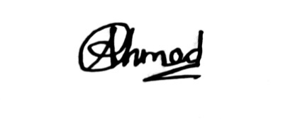

Advisor